**Linux Programming**

**lab 08**

**Sree Krishna Theja B**

**17MIS1004**

**Fork**

Code:

#include<stdio.h>

#include <sys/types.h>

#include <unistd.h>

int main()

{

    int pid;

    pid=fork();

    if(pid==0)

    printf("Hello world from child\n");

    else

    printf("Hello world from parent\n");

}

Output:

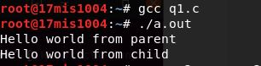

2. **EXECCVE**

**File Name: execve.c**

#include<stdio.h>

#include<stdlib.h>

#include<unistd.h>

int main()

{

    int a=fork();

    if(a==0)

    execve("ex2",NULL,NULL); //pass ex2.c object here

}

**File Name: ex2.c**

#include<stdio.h>

int main()

{

    int i,a;

    int m=0;

    for(i=1;i<=5;i++)

    {

        m=m+i;

    }

    printf("%d\n",m);

}

Output:

C:\Users\B.Sreekrishnateja\Downloads\1004-2(2).JPG

**3. Executing cat command using execve:**

**CODE:**

#include<stdio.h>

#include<stdlib.h>

int main()

{

    char* argv[3] = {"/bin/cat", "ex2.c", NULL};

    execve("/bin/cat", argv, NULL);

}

Output:

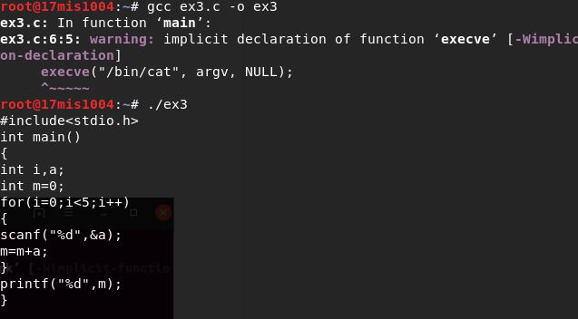

4.

Code:

#include<stdio.h>

#include<stdlib.h>

#include<sys/wait.h>

int main(void)

{

    pid_t pid;

    int status;

    if((pid=fork())<0)

    {

        printf("Error");

    }

    else if(pid==0)

    {

        exit(0);

    }

    if(wait(&status!=pid))

    {

        printf("wait Error\n");

    }

    //pr_exit(status);

    if((pid=fork())<0)

    {

        printf("Fork Error");

    }

    else if(pid==0)

    {

        abort();

    }

}

Output:

